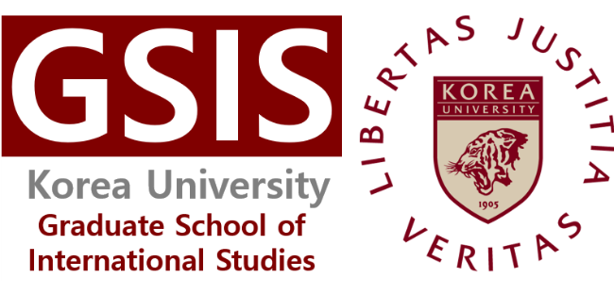
Agreement for Collection and Use of Personal Data
For the purposes of admission consideration at Korea University, Graduate School of International Studies (GSIS), your personal data is intended to be collected and used in the following manners.

Collection and Use of Personal Data
Items to be Collected | All information provided through the online application (name, gender, e-mail address, date of birth, photo, Korean visa status, mailing address, telephone number, mobile number, citizenship, passport number, Parents citizenship, education background, academic career [if applicable], employment experience [if applicable], English test scores, letter of recommendation, Statement of Purpose, sponsor’s information etc.), information regarding Bachelor’s and Master’s degrees (diploma, transcript, etc.); proof of English language proficiency; Certificate of bank deposit; copy of Alien registration card; family-related information(birth certificate, certificate of family relations); photos; Certificate of Entry & Exit (International Student B only); education verification information.
Purpose(s) of  Collection and Use | Application and consideration for admission at Korea University GSIS
Period of Retention  and Use | 10 years

You have the right to reject agreement to the collection and use of your personal data, however, you will not be able to apply for admission to Korea University GSIS.
Do you agree to the collection and use of your personal data as specified above? Agree
Processing of Unique Identification Information
Items to be Collected | Passport Number (Copy of Passport)
Purpose(s) of  Collection and Use | Application and consideration for admission at Korea University GSIS
Period of Retention  and Use | 10 years

You have the right to reject agreement to the collection and use of your personal data, however, you will not be able to apply for admission to Korea University GSIS.
Do you agree to the collection and use of your personal data as specified above? Agree
Name: Signature: Date:

