1.1.1. Credit Transfer Approval Application for Other Universities (Portal - College Registration/Graduation - Transcript Details)

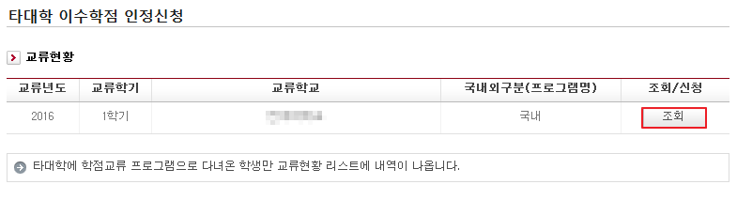
Only students who have participated in a foreign university exchange program will have current status list categories show up on their screen like in the picture depicted above. Afterwards, if you click “view(조회)”, the foreign university credit transfer approval application form will appear on the screen as shown in the next picture below.
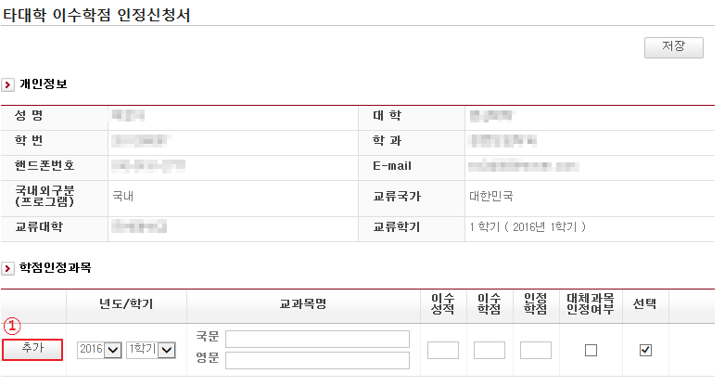

- Enter the year/semester, the subjects, and the completion grade for the credit approval of each course taken. Click the add(추가) button to add courses. If the student attended a domestic exchange program, the student will enter the information in Korean and English. If the student attended and exchange program at a university overseas, the student will enter the information only in English. Once the completed grade and credit are entered, the credit will be automatically approved following the corresponding college’s credit transfer rate.

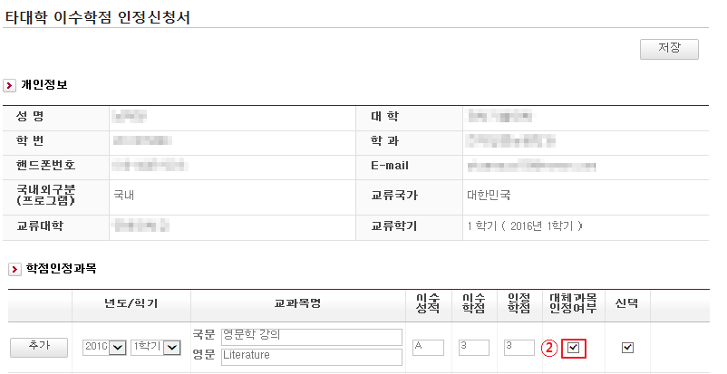

2. If the subject is recognized as an established course on campus and thus can be approved to be a replacement course, check the column labeled “replacement course approved”.

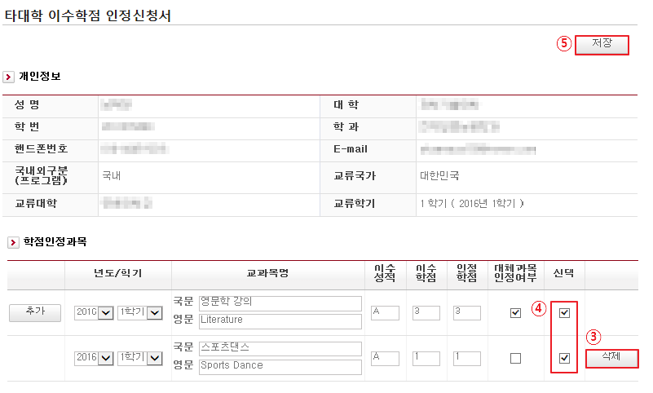

3. Using the delete(삭제) button, you can delete a course
4. Once you have finished entering all the necessary information, select(checkmark on 선택) all the items
5. Click the “save(저장)” button to save

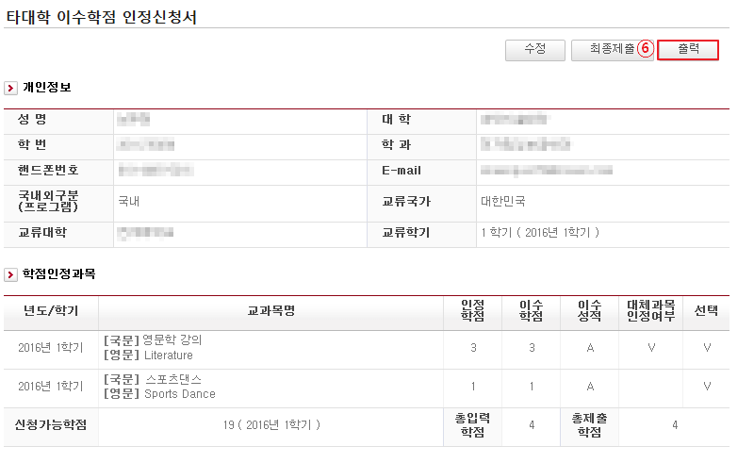

6. Print (출력)

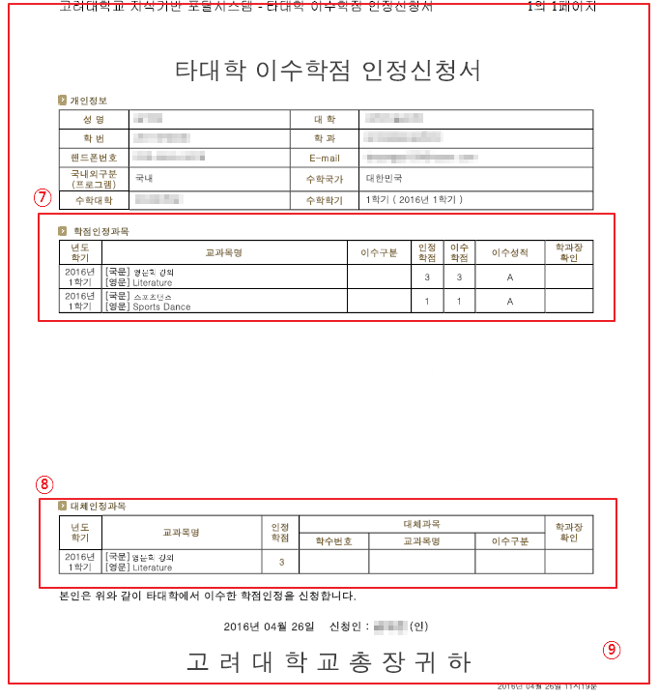

7. After printing, stop by the department administration office, write down the course type, and receive the dean’s confirmation (If you receive approval for the double major or interdisciplinary studies, you must receive confirmation from your corresponding dean or department head).

8. If you have applied for a replacement course approval, you must follow the dean’s instructions, write down the course information, and receive the dean’s approval.

9. Scan

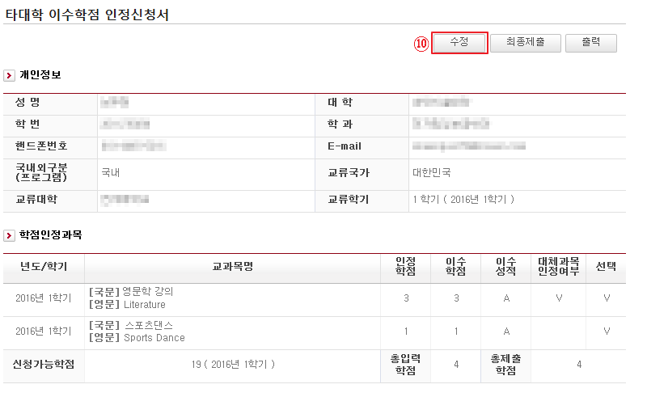

10. Click the edit button

11. Combine and attach the other university credit approval application form, the original transcript with the GPA (grading scale), and the syllabus documents attached below.

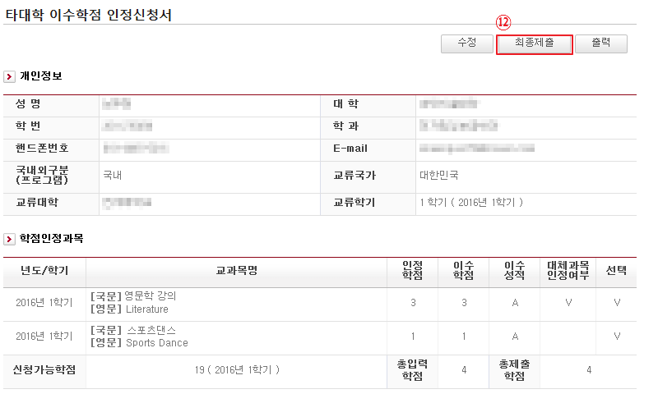

12. Final Submission

[Note]
- For more information regarding foreign university credits approval, visit studyabroad.korea.ac.kr

