Course Information

2022 Seoul Academy of
International Law

July 4 (Mon.) – July 15 (Fri.), 2022
Seoul, Republic of Korea

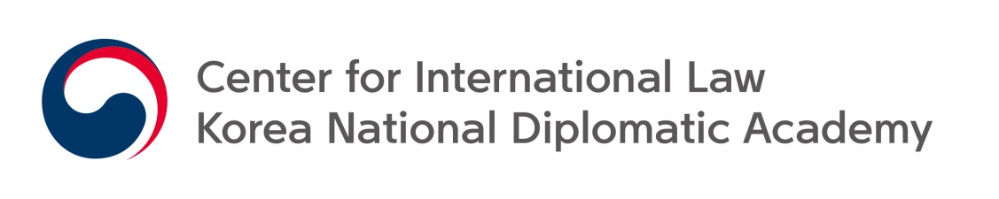

CONTENTS

Ⅰ. Program Overview 3

Ⅱ. Course Information and Terms of Participation 4
- Course Information 4
- Terms of Participation 6
- Rules and Policies 7

Ⅲ. Contacts 8

Ⅰ. Program Overview

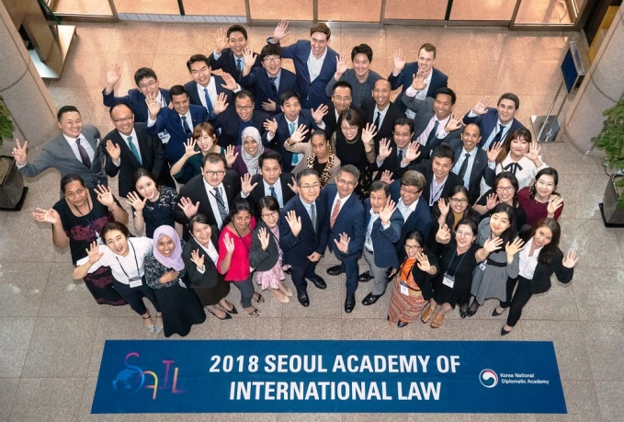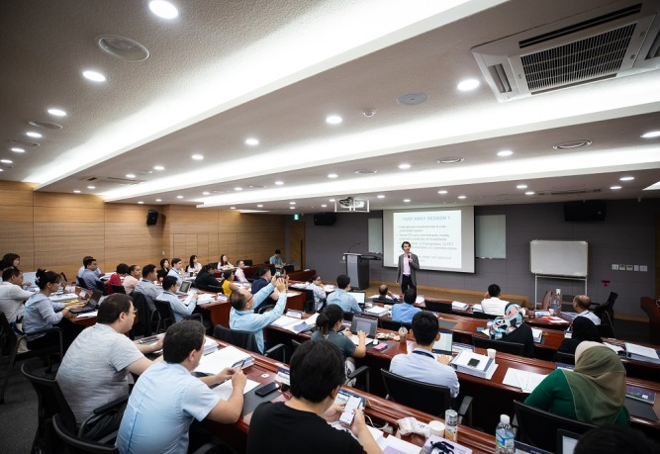

❏ Program Objectives
The Seoul Academy of International Law (SAIL) is a training program organized by the Center for International Law (CIL) at the Korea National Diplomatic Academy (KNDA) of the Ministry of Foreign Affairs of the Republic of Korea. It provides courses lectured by prominent scholars and practitioners in the field of international law to the participants from Asia and the Pacific region. The objective of the program is to promote greater understanding on the current trends in international law among those involved in international law practice. In an effort to establish the rule of law in the region on a more solid basis, the SAIL aims, in particular:
- To enhance the participants’ understanding about international law
- To promote exchanges of views on contemporary international law
- To strengthen future cooperation and networks between the participants and the ROK
- To facilitate sharing knowledge in participating countries’ foreign policies relating to current international legal issues

❏ Participants
About 40 participants in the program come from various countries in Asia and the Pacific, and range widely from government officials, including diplomats and legal practitioners, to scholars, researchers as well as graduate students.

Ⅱ. Course Information and Terms of Participation

1. Course Information

❏ Date and Venue

- Date: July 4 (Mon.) – 15 (Fri.), 2022
- Venue: Korea National Diplomatic Academy (Seoul, Korea)

❏ Participants: 38 participants from 24 countries in Asia and the Pacific
- Australia, Bangladesh, Brunei, Cambodia, China, Fiji, Indonesia, Japan, Kazakhstan, Laos, Malaysia, Mongolia, Nepal, New Zealand, Papua New Guinea, Philippines, Singapore, Sri Lanka, Thailand, Timor-Leste, Turkey, Uzbekistan, Vietnam, and Republic of Korea

❏ Lecturers and Courses
Benedict Kingsbury  Professor, New York University | Global Governance and International Law
Bhupinder S. Chimni  Professor, Jindal Global Law School | Third World Approaches to International Law
Dapo Akande  Professor, University of Oxford | International Criminal Law
Jin-hyun Paik  Professor, Seoul National University | Law of the Sea
Jutta Brunnée  Professor, University of Toronto | International Environmental Law
Nohyoung Park  Professor, Korea University | Cybersecurity and International Law
WHO Representative  WHO | Global Health Law and the WHO
Won-soo Kim  Professor, Incheon National University | UN and International Law
ICRC Representative  ICRC | New Technology and International Humanitarian Law
❏ Lecture Timetable
WEEK 1 | 7/4 (Mon) | 7/5 (Tue) | 7/6 (Wed) | 7/7 (Thu) | 7/8 (Fri)
09:30-  11:30 | Opening Ceremony  &  Orientation | Law of the Sea (1)  Prof. Jin-hyun Paik | UN & International  Law (2)  Prof. Won-soo Kim | International Criminal Law (2)  Prof. Dapo Akande | Field Trip
13:00-  15:00 | UN & International  Law (1)  Prof. Won-soo Kim | Law of the Sea (2)  Prof. Jin-hyun Paik | International Criminal Law (1)  Prof. Dapo Akande | International Criminal Law (3)  Prof. Dapo Akande
15:15-  17:15 |  |  | Third World Approaches to International Law (1)  Prof. Bhupinder S. Chimni | Third World Approaches to International Law (2)  Prof. Bhupinder S. Chimni
WEEK 2 | 7/11 (Mon) | 7/12 (Tue) | 7/13 (Wed) | 7/14 (Thu) | 7/15 (Fri)
09:30-  11:30 | Global Governance and International  Law (1)  Prof. Benedict Kingsbury | Global Governance and International  Law (2)  Prof. Benedict Kingsbury | Global Governance and International  Law (3)  Prof. Benedict Kingsbury | Cybersecurity & International  Law (1)  Prof. Nohyoung Park | Cybersecurity & International  Law (2)  Prof. Nohyoung Park
13:00-  15:00 | International Environmental Law (1)  Prof. Jutta Brunnée | International Environmental Law (2)  Prof. Jutta Brunnée | International Environmental Law (3)  Prof. Jutta Brunnée | New Technology & International Humanitarian Law (1)  ICRC Representative | New Technology & International Humanitarian Law (2)  ICRC Representative
15:15-  17:15 |  | Global Health Law and the WHO (1)  WHO Representative | Global Health Law and the WHO (2)  WHO  Representative |  | Closing  Ceremony
*Lecturers and schedules are subject to change.

2. Terms of Participation

❏ Language of Instruction: English

❏ Qualification of Applicants

- Public officers, including diplomats and legal practitioners in charge of international legal affairs, with over 5 years of work experience
- Researchers and scholars in international legal affairs in institutions and universities
- Graduate students majoring in international legal affairs in academic institutions and universities
- Proficiency in spoken English
- Knowledge and experiences in international law

❏ Regulations

- Participants should participate in the program to the best of their abilities.
- Participants should refrain from engaging in political activities or any form of employment for profit or gain.
- Participants must return to their home country upon completion of the program.
- Participants should not extend their stay beyond the length of the program for personal reasons.
- Participants are not permitted to change the flight schedule arranged by the CIL for personal convenience.
- Participants should not accompany any member of their family to the program.
- Participants are to assume responsibility for any personal expenses incurred.
- Participants are required to strictly observe the course schedule and abide by the rules and regulations stipulated by the CIL in respect to the program.
- Participants should cooperate in preventing any sexual harassment.

❏ Travel and Accommodation

The CIL will cover for participants accommodation and such travel expenses as round-trip airfare, accommodation, round-trip airport transportation, field trip, and per diem. (*Round-trip airfare will be provided to all participants except those from the following countries: Australia, Brunei, Japan, New Zealand , and Singapore)

3. Rules and Policies

The participants in the Seoul Academy of International Law (hereinafter participants) are expected to have read, abide by, and respect the following rules and policies that the CIL endorses in implementing the program. It is also understood that the participants are provided with the highlights of such rules and policies on the occasion of the program orientation.
- Privacy and Copyright Policy
Unless the participants state otherwise in writing, it is considered that:
- The CIL may provide and disclose the participants’ information, including the name, nationality, organization and position of the participants, to relevant entities within the limit provided by the CIL’s policy or regulations thereof;
- The CIL possesses the right of using all the documents and information provided by the participants for the operational purposes of the Seoul Academy of International Law (hereinafter the Academy), including their duplication, translation, distribution, and/or posting to websites.
- Punctuality and Attendance Policy
- Participants will need to be punctual for any classes that the Academy offers.
- Certificates of Attendance are awarded at the end of the Academy only to those who have attended at least seventy (70) percent of the classes.
- Policy on Misconduct
- Any form of harassment or insult, including but not limited to misconduct arising out of racial/ethnic, gender or class discrimination, whether it be physical or verbal, will be dealt with in accordance with Korean laws.
- Sexual harassment, defined as a form of behavior characterized by sexually connotative words, acts or gestures that could undermine individual dignity and by which the victim takes offense, is regarded as a serious misconduct and will be acted upon accordingly.
- All participants are encouraged to report to the CIL immediately participants’ such misconduct as explained above, especially when damage should occur from misconduct by the participants.
- Security and Well-being Policy
Participants are solely responsible for their own personal belongings, safety, health and well-being, and are asked to conduct themselves accordingly.
- General Rules
- Participants shall not engage in political activities and any form of employment for profit or gain for the duration of the courses at the Academy.
- Participants are liable for any damage whatsoever to any property that arises from the carelessness, negligence, omission or default of the participants for the duration of the courses at the Academy.

Ⅲ. Contacts

For any inquiry, please contact Center for International Law by the following methods:
- Tel: +82-2-3497-7618
- E-mail: cil@mofa.go.kr

