KU GSIS Graduation Checklist

Student Name : |  | Student ID Number :
Degree Program : | Master of Arts in International Studies | Major :
Track : | Thesis | Thesis Advisor :

※ Please write down the accurate NAME and CODE of the courses you have taken on the table below.
Required Courses |  | Courses you have taken |  | Note
CORE Compulsories | 6 | CORE Compulsories |  | 1. You must take all CORE courses  during the 1st & 2nd Semesters.  (except Thesis Research I).  2. The students who admitted to KU GSIS from Fall 2021 must take GRA511.
IRC010/013 Research Methods/ II | 3 | ex) IRC010 Research Methods
IRC011 Thesis Research I | 3
CORE Electives (3 out of 4) | 9 | CORE Electives
IRC020 International Business | 3
IRC030 International Economics | 3
IRC040 World Politics | 3
IRC070 Introduction to IDC | 3
MAJOR Electives | 15 | MAJOR Electives
Major Elective ① | 3 | ex) IDC318 Business and Human Rights
Major Elective ② | 3
Major Elective ③ | 3
Major Elective ④ | 3
Major Elective ⑤ | 3
Area Studies | 6 | Area Studies
Area Studies ① | 3
Area Studies ② | 3
General Electives | 4 (3) | General Electives
General Electives | 3
GRA511 Introduction to Graduate Studies | 1
Total Credits | 40 (39) | Total Credits

The Checklist above is completed by Student Name on MM (Month) / DD (Date) / YYYY (Year).

※ Please leave the below tables BLANK, which will be assessed by the administrative office.
※ If you have any question regarding the result of the assessment, please contact the administrative office.
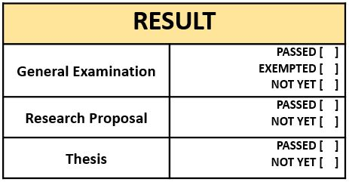
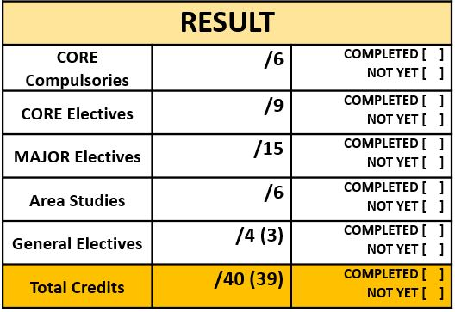
By. KU GSIS Administrative Office

Date
Signature

The assessment tables above are completed by Officer Name on MM (Month) / DD (Date) / YYYY (Year).

