KU GSIS Graduation Checklist

Student Name : |  | Student ID Number :
Degree Program : | PhD in International Commerce | Major :
Track : | Thesis | Thesis Advisor :

※ Please write down the accurate NAME and CODE of the courses you have taken on the table below.
Required Courses |  | Courses you have taken |  | Note
CORE Courses | 9 | CORE Courses |  | The students who admitted to KU GSIS from Fall 2021 must take GRA511.
IAC701 Independent Study I | 3 | ex) IAC701 Independent Study I
IAC702 Independent Study II | 3
IRC012 Thesis Research II | 3
MAJOR Required | 9 | MAJOR Required
IAC801 or IAC802 Advanced Research Methods | 3
Major Required - IIC ① | 3
Major Required - IIC ② | 3
MAJOR Electives | 12 | MAJOR Electives
Advanced Seminar ① | 3
Advanced Seminar ② | 3
Advanced Seminar ③ | 3
Advanced Seminar ④ | 3
General Electives | 7 (6) | General Electives
General Electives | 6
GRA511 Introduction to Graduate Studies | 1
Total Credits | 37 (36) | Total Credits

The Checklist above is completed by Student Name on MM (Month) / DD (Date) / YYYY (Year).
※ Please leave the below tables BLANK, which will be assessed by the administrative office.
※ If you have any question regarding the result of the assessment, please contact the administrative office.
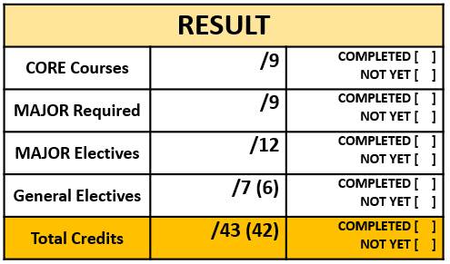
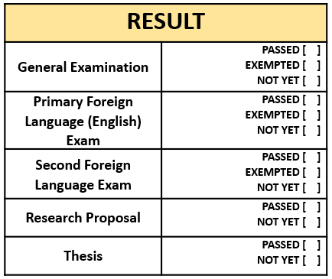
By. KU GSIS Administrative Office
Date
Signature

The assessment tables above are completed by Officer Name on MM (Month) / DD (Date) / YYYY (Year).

