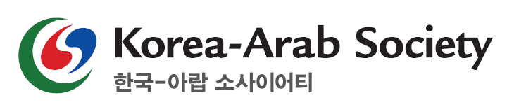
Application Form for Korea-Arab Youth Supporters
Name
Date of Birth |  |  |  | Nationality
Contact | Mobile
 | Email
Address
University | Period (mm/yy~mm/yy) |  | Name of University |  | Department | Graduation status
 | ~
 | ~
Account of personal social networks
Instagram
Facebook
Others
Personal Introduction
1. Please describe your motivation for applying to this program.
2. Please describe a sector you would like to create for social media content when you are selected as a supporter of Korea-Arab Society.
3. Please make a social media card news about Arab(one topic from politics, economics, society or culture) and upload it on your personal social network, then provide the URL of the account.
※ Account profile must be “open to public” and it is essential to put hashtags such as #arab #korearabsociety #extracurriculars #arabpolitics(or arabeconomics or arabsociety or arabculture etc.).

